LEVEL-3

TASK-2

CUSTOMER PREFERENCE ANALYSIS

CODE

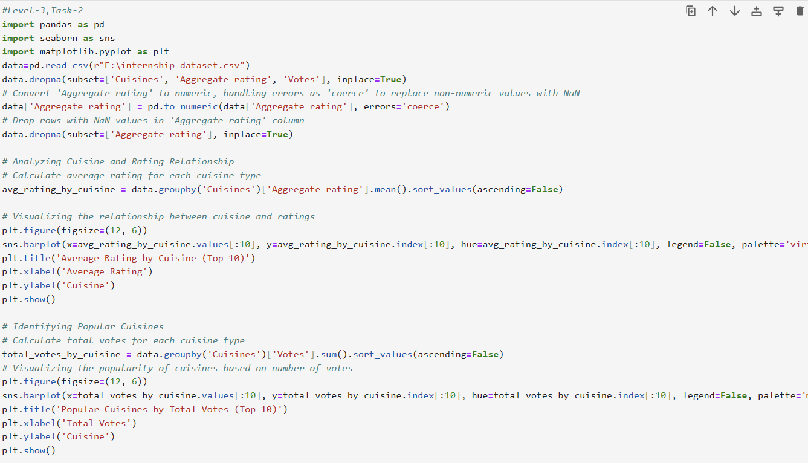

OUTPUT

